


Data Compliance Test (DCT)
Test Cases for
Allergy Record

<HCP Name>

Table of Contents
1 Testing Instructions to HCPs 3
1.1 Self-Service Testing Phase 3
1.2 Final Testing Phase 3
1.3 Preparation DCT Test Report 4
2 Test Case Details 5
AL1-001 5
AL1-002 13
3 Appendix – Sample Messages 17
4 Appendix – Testing HCP and HCRs Information 19
5 Appendix – Sample Results in eHR Viewer (EVE) 19
6 Appendix – Actual Data Values (Sample) 23

Testing Instructions to HCPs

Self-Service Testing Phase
- After development of the data upload programmes, you can use the Self-Service test accounts and test HCRs provided by eHealth for connection to the eHealth testing environment and proceed with the self-service testing.
- You can proceed with the Self-service test at your own pace by following this Self-Service Testing Guide and using the test cases provided in section 2.
- You can verify the correctness and completeness of the data upload by:
  - checking the interface files / messages generated in your system against the sample expected results of interface files /messages for all test cases as provided;
  - checking the results on eHR Viewer (EVE) by logging into the testing eHealth with the provided test account; and
  - checking the upload status through Process Summary and Exception Report in eHR Inbox by logging into the testing eHealth.
- For data fields requiring eHR Codex values, you can refer the Code Sets provided with the Self-Service Kit.
- For details of technical requirements of the data interface files, please refer to the ‘Developer Quick Guide for Allergy Data Upload to eHealth.docx’.
- You are required to perform the test cases that are relevant to the data compliance level supported by your clinic.
- You are required to perform the first batch of data upload by Data Materialization (DM) mode. DM mode is denoted in the interface by a fixed value BL-M in HL7 OBX.4
- You should use Incremental Load (INC) mode for the second batch of data upload to update the previously uploaded records. INC mode is denoted in the interface by a fixed value BL in HL7 OBX.4.
- Since the DM mode would replace the corresponding records previously uploaded to eHealth, you may repeat your testing unlimited number of times by uploading the first batch by DM mode.
- It should be noted that the data field “Record Key” should be unique for each allergy record, while each allergy record can carry multiple allergen and each allergen can carry multiple allergic reactions.
- When all required test cases can be completed smoothly and correctly in this phase, you can proceed to the Final Testing Phase and submit production environment setup form to eHR DCT Support for preparation.

Final Testing Phase
- You can start the Final Testing Phase once all test cases in the Self-Service Testing phase are passed.
- You should start Final Test by executing the test cases provided in section 2 with Final Testing HCRs provided by eHR DCT Support.
- You can verify the correctness and completeness of testing results by checking results in eHR Viewer (EVE) and the upload status through Process Summary, Exception Report and Re-grade Report in eHR Inbox.
- For Allergy DCT test cases, there are TWO batches of data files / transactions to be uploaded to the testing eHealth. The required records must be correctly uploaded from these 2 consecutive batches respectively.
- The Final Test will be considered PASSED if all the following criteria are met:
  - The TWO batches of test data files are uploaded consecutively in the correct sequence. The second batch of data files/transactions must be submitted after completion of processing of the first batch by eHealth.
  - No additional data files / transactions are uploaded in between or after the uploads of the above two batches of data files / transactions to amend any records.
  - No exception records are reported from the uploads.
  - No manual interventions have been made to the data files / transactions.
- If the Final Test failed, you can re-attempt the Self-Service Test and Final Test until a successful run can be completed.

Preparation DCT Test Report
- Once you have successfully passed the Final Test based on the above criteria, you should complete this document by attaching the below items to this document at the appropriate space provided:
  - Actual data files uploaded
  - Screen-shot of each test case
- You are required to submit this completed ‘DCT Test Cases’ document to eHR DCT Support for further processing. eHR DCT Support will provide feedback within 10 working days.

Test Case Details
1 | Test Case ID | AL1-001
 | Function Description | HCP has received the sharing consents from testing HCRs, then perform first data upload of HCRs’ clinical records to eHealth by DM Mode.
 | Subsequent case of | N/A
 | Testing Assumption | - HCR1-HCR9 have already given sharing consents to your outpatient clinic.  - The EMR system (EMRS) will upload Batch 1 data files to eHealth with all allergy records of <HCR1> - <HCR9> created by DM mode.
 | Test Actions | HCP creates below allergy records in EMR system:  For level 3 data, please perform test cases 1a – 1f.  For level 2 data, please perform test cases 1g - 1i.
 | Test Actions | 1a | (Level 3 data) Input in the HCP’s EMRS a ‘Certain’ allergy record for ‘Penicillins’ with ‘Rash’ reaction for <HCR1>. The clinical record uploaded to eHealth should contain the follows:  - Type of allergen code = Drug  - Type of allergen description = Drug allergen  - Type of allergen local description = Description used in the EMRS  - Allergen - recognised terminology name = HKCTT  - Allergen identifier - recognised terminology = 7002240  - Allergen description - recognised terminology = Penicillins  - Allergen local code = (Optional)  - Allergen local description = Description used in the EMRS e.g. Penicillins  - Level of certainty code = C  - Level of certainty description = Certain  - Level of certainty local description = Description used in the EMRS  - Allergic reaction code = 21  - Allergic reaction description = Rash  - Allergic reaction local description = Description used in the EMRS  - Allergen remark = (Blank)  == Actual data values (Refer to “Appendix - Actual Data Values (Sample)” for details)  Note: For HCPs using only RPP in local system, please upload a drug from the penicillins group.
 | Test Actions | 1b | (Level 3 data) Input in the EMRS a ‘Suspected’ allergy record for a single ingredient VTM drug ‘Aminophylline’ (ASMETON "STRONG" CAP (CHINA)), with ‘Pruritus’ reaction for <HCR2>. The clinical record uploaded to eHealth must contain the follows:  - Allergen - recognised terminology name = HKCTT / RPP  - Allergen identifier - recognised terminology = 6010636 / 53168  - Allergen description - recognised terminology = Aminophylline / ASMETON "STRONG" CAP (CHINA)  - Allergen local code = (Optional)  - Allergen local description = Description used in the EMRS  Please provide below optional data field(s) (if applicable)  - Type of allergen code = Drug  - Type of allergen description = Drug allergen  - Type of allergen local description = Description used in the EMRS  - Level of certainty code = S  - Level of certainty description = Suspected  - Level of certainty local description = Description used in the EMRS  - Allergic reaction code = 20  - Allergic reaction description = Pruritus  - Allergic reaction local description = Description used in the EMRS  - Allergen remark = Test case 2b  == Actual data values (Refer to “Appendix - Actual Data Values (Sample)” for details)
 | Test Actions | 1c | (Level 3 data) Input in the EMRS a ‘Suspected’ allergy record for a multi-ingredient VTM drug ‘Calamine + Zinc Oxide’ (CALACARE LOTION) with ‘Swelling in lower limbs’ reaction for <HCR3>. The clinical record uploaded to eHealth must contain the follows:  - Type of allergen code = Drug  - Type of allergen description = Drug allergen  - Type of allergen local description = Description used in the EMRS  - Allergen - recognised terminology name = HKCTT / RPP  - Allergen identifier - recognised terminology = 6004172 / 66422  - Allergen description - recognised terminology = Calamine + Zinc Oxide /  - CALACARE LOTION  - Allergen local code = (Optional)  - Allergen local description = Description used in the EMRS  - Level of certainty code = S  - Level of certainty description = Suspected  - Level of certainty local description = Description used in the EMRS  - Allergic reaction code = 32  - Allergic reaction description = Other swelling  - Allergic reaction local description = Description used in the EMRS  - Allergen remark = Swelling in lower limbs  Remark: Allergen remark would be shown when mouse-over the “i” button (i.e. information button). Screen capture of showing the allergen remark is required.  == Actual data values (Refer to “Appendix - Actual Data Values (Sample)” for details)
 | Test Actions | 1d | (Level 3 data) Input in the EMRS an invalid recognised terminology for <HCR4>: a ‘Certain’ allergy to a single ingredient TN drug ‘Voltaren’ (diclofenac sodium) with ‘Rash’ reaction. The incorrect recognised description highlighted in RED below should be set up (override the correct description) in the EMRS beforehand just for this test case and should be reverted to the correct description afterwards. The clinical record uploaded to eHealth would contain the follows:  - Allergen - recognised terminology name = HKCTT / RPP  - Allergen identifier - recognised terminology = 6000032 / 00170  - Allergen description - recognised terminology = Voltaren 123 / VOLTAREN TAB 25 MG ENTERIC COATED 123  - Allergen local code = (Optional)  - Allergen local description = Description used in the EMRS  Please provide below optional data field(s) (if applicable)  - Type of allergen code = Drug  - Type of allergen description = Drug allergen  - Type of allergen local description = Description used in the EMRS  - Level of certainty code = S  - Level of certainty description = Suspected  - Level of certainty local description = Description used in the EMRS  - Allergic reaction code = 21  - Allergic reaction description = Rash  - Allergic reaction local description = Description used in the EMRS  - Allergen remark = Test case 1d  Remark: Record will be shown in the “Re-grade Report” as Allergen description - recognised terminology does not match the Allergen description - recognised terminology in eHealth.  == Actual data values (Refer to “Appendix - Actual Data Values (Sample)” for details)
 | Test Actions | 1e | (Level 3 data) Input in the EMRS a ‘Certain’ allergy record for a free-text drug allergen ‘Altagesic ointment’ with ‘Rash’ reaction for <HCR5>. The clinical record uploaded to eHealth must contain the follows:  - Allergen local code = (Optional)  - Allergen local description = Altagesic ointment  Please provide below optional data field(s) (if applicable)  - Type of allergen code = Drug  - Type of allergen description = Drug allergen  - Type of allergen local description = Description used in the EMRS  - Level of certainty code = C  - Level of certainty description = Certain  - Level of certainty local description = Description used in the EMRS  - Allergic reaction code = 21  - Allergic reaction description = Rash  - Allergic reaction local description = Description used in the EMRS  - Allergen remark = Test case 1e  Remark: Record will be shown in “Re-grade Report” as Allergen – Recognised Terminology data fields are blank.  == Actual data values (Refer to “Appendix - Actual Data Values (Sample)” for details)
 | Test Actions | 1f | (Level 3 data) Input an allergy record without recognised terminology in the EMRS for <HCR6>: a ‘Suspected’ allergy to a free-text non-drug allergen ‘Fish’ with ‘Rash’ reaction. The clinical record uploaded to eHealth would contain the follows:  - Allergen local code = (Optional)  - Allergen local description = Fish  Please provide below optional data field(s) (if applicable)  - Type of allergen code = Non-drug  - Type of allergen description = Non-drug allergen  - Type of allergen local description = Description used in the EMRS  - Level of certainty code = S  - Level of certainty description = Suspected  - Level of certainty local description = Description used in the EMRS  - Allergic reaction code = 21  - Allergic reaction description = Rash  - Allergic reaction local description = Description used in the EMRS  - Allergen remark = Test case 1f  Remark: Record will be shown in “Re-grade Report” as Allergen – Recognised Terminology data fields are blank.  == Actual data values (Refer to “Appendix - Actual Data Values (Sample)” for details)
 | Test Actions | 1g | (Level 2 data) Input an allergy record without recognised terminology in the EMRS for <HCR7>: a ‘Certain’ drug allergy to ‘Panadol’ with ‘Pruritus’ reaction. The clinical record uploaded to eHealth would contain the follows:  - Type of allergen local description = Drug  - Allergen local code = (Optional)  - Allergen local description = Panadol  - Level of certainty local description = Certain  - Allergic reaction local description = Pruritus  == Actual data values (Refer to “Appendix - Actual Data Values (Sample)” for details)
 | Test Actions | 1h | (Level 2 data) Input an allergy record without recognised terminology in the EMRS for <HCR8>: a ‘Suspected’ drug allergy to ‘Augmentin’ with ‘Rash on hands’ reaction. The clinical record uploaded to eHealth would contain the follows:  - Type of allergen local description = Drug  - Allergen local code = (Optional)  - Allergen local description = Augmentin  - Level of certainty local description = Suspected  - Allergic reaction local description = Rash  - Allergen remark = Rash on hands  Remark: Allergen remark would be shown when mouse-over the “i” button (i.e. information button). Screen capture of showing the allergen remark is required.  == Actual data values (Refer to “Appendix - Actual Data Values (Sample)” for details)
 | Test Actions | 1i | (Level 2 data) Input an allergy record without recognised terminology in the EMRS for <HCR9>: a ‘Certain’ allergy to a non-drug item ‘Fish’ with ‘Rash’ reaction. The clinical record uploaded to eHealth would contain the follows:  - Type of allergen local description = Non-drug  - Allergen local code = (Optional)  - Allergen local description = Fish  - Level of certainty local description = Certain  - Allergic reaction local description = Rash  == Actual data values (Refer to “Appendix - Actual Data Values (Sample)” for details)
 | Expected eMR System Behavior | - (Level 3 data) HCP’s EMRS would upload Batch 1 data files with all allergy records created in 1a-1f by DM mode.  (Level 2 data) HCP’s EMRS would upload Batch 1 data files with all allergy records created in 1g-1i by DM mode.  - Batch 1 data files should include the below files: <samples>  - Participant List (PL)  - Data File (DF)  - HL7 message with signature  - Zip File (embedded PL, DF and HL7 message files)  - Zip Control File (contains the filenames of PL, DF and HL7 message)  - EMRS uploads Batch 1 data files (‘Zip File’ and ‘Zip Control File') to eHealth.  - HCP verifies the data upload status by reviewing the 'Process Summary Report' and 'Exception Report' in eHR Inbox.  - HCP verifies the completeness and correctness of data uploaded in eHR Viewer.
 | Results Verification | - HCP verifies if the uploaded records can be properly viewed in eHR Viewer (EVE) and reviews if the data batches uploaded can be processed successfully or rejected through ‘Process Summary’, ‘Exception Report’ and ‘Re-grade Report’ in eHR Inbox.
 | Actual Result  (Screenshot / Attachment) | Data Files Uploaded:  <Attached the Zip file and Control file; password to unzip the file>
 | Actual Result  (Screenshot / Attachment) | Attachment/Screenshot:  <Attached the screen shots of records uploaded in eHR Viewers>
 | Remark | <State your reasons/ justification for exemption with case number>
 | Testing Date | <Provided by HCP>
 | Verified By | <Provided by HCP>

2 | Test Case ID | AL1-002
 | Function Description | There are subsequent changes to the HCRs’ clinical records already uploaded in Batch 1. HCP then uploads incremental changes to eHealth by INC Mode.
 | Subsequent case of | AL1-001
 | Testing Assumption | - HCP has already verified that the Batch 1 data upload has been completed successfully.
 | Test Actions | HCP updates below allergy records in their EMR system (EMRS):  For level 3 data, please perform test cases 2a - 2d  For level 2 data, please perform test cases 2e - 2g.
 | Test Actions | 2a | (Level 3 data) Add in EMRS allergy remarks of ‘Rash on hand’ for <HCR1> to test case 1(a) above as follows:  - (Add) Allergen remarks = Rash on hands  == Actual data values (Refer to “Appendix - Actual Data Values (Sample)” for details)
 | Test Actions | 2b | (Level 3 data) Update test case 1(c) for <HCR3> on certainty, allergic reaction and allergen remarks as follows:  - (Update) Level of certainty code = C  - (Update) Level of certainty description = Certain  - (Update) Level of certainty local description = Description used in the EMRS  - (Update) Allergic reaction code = 20  - (Update) Allergic reaction description = Pruritus  - (Update) Allergic reaction local description = Description used in the EMRS  - (Update) Allergic reaction code = 21  - (Update) Allergic reaction description = Rash  - (Update) Allergic reaction local description = Description used in the EMRS  - (Update) Allergen remark = On hand only  Remark: Allergen remark would be shown when mouse-over the “i” button (i.e. information button). Screen capture of showing the allergen remark is required.  == Actual data values (Refer to “Appendix - Actual Data Values (Sample)” for details)
 | Test Actions | 2c | (Level 3 data) Input in the EMRS a ‘Certain’ drug allergy record for ‘Augmentin’ with ‘Pruritus’ reaction for <HCR4>. The clinical record uploaded to eHealth should contain the follows:  - (Add) Type of allergen code = Drug  - (Add) Type of allergen description = Drug allergen  - (Add) Type of allergen local description = Description used in the EMRS  - (Add) Allergen - recognised terminology name = HKCTT / RPP  - (Add) Allergen identifier - recognised terminology = 6004544 / 44027  - (Add) Allergen description - recognised terminology = Augmentin (amoxicillin (as trihydrate) + clavulanate (as potassium)) / AUGMENTIN TAB 625MG  - (Add) Allergen local code = (Optional)  - (Add) Allergen local description = Description used in the EMRS  - (Add) Level of certainty code = C  - (Add) Level of certainty description = Certain  - (Add) Level of certainty local description = Description used in the EMRS  - (Add) Allergic reaction code = 20  - (Add) Allergic reaction description = Pruritus  - (Add) Allergic reaction local description = Description used in the EMRS  == Actual data values (Refer to “Appendix - Actual Data Values (Sample)” for details)
 | Test Actions | 2d | (Level 3 data) Delete in EMRS the incorrect allergy record in test case 1(e) for <HCR5> uploaded in Batch 1 as follows:  - Delete allergen reason = Wrong input  == Actual data values (Refer to “Appendix - Actual Data Values (Sample)” for details)
 | Test Actions | 2e | (Level 2 data) Input in the HCP’s EMRS an additional allergy record for <HCR7>: ‘Certain’ drug allergy record for ‘Voltaren’ with ‘Rash’ reaction. The clinical record uploaded to eHealth should contain the follows:  - (Add) Type of allergen local description = Drug  - (Add) Allergen local code = (Optional)  - (Add) Allergen local description = Voltaren  - (Add) Level of certainty local description = Certain  - (Add) Allergic reaction local description = Rash  == Actual data values (Refer to “Appendix - Actual Data Values (Sample)” for details)
 | Test Actions | 2f | (Level 2 data) Update Certainty, Allergic Reaction and Allergen Remark of test case 1(e) for <HCR8> as follows:  - (Update) Level of certainty local description = Certain  - (Update) Allergic reaction local description = Pruritus  - (Update) Allergen remark = Pruritus on lower limbs  == Actual data values (Refer to “Appendix - Actual Data Values (Sample)” for details)
 | Test Actions | 2g | (Level 2 data) Delete in EMRS the incorrect allergy record in test case 1(i) for <HCR9> as follows:  - Delete allergen reason = Wrong input  == Actual data values (Refer to “Appendix - Actual Data Values (Sample)” for details)
 | Expected eMR System Behavior | - (Level 3 data) HCP’s EMR system generated Batch 2 INC data file with 2a-2d transactions to eHealth.  - (Level 2 data) HCP’s EMR system generated Batch 2 INC data file with 2e-2g transactions to eHealth.  - Batch 2 data files should include below files: <samples>  - Participant List (PL)  - Data File (DF)  - HL7 message with signature  - Zip File (embedded PL, DF and HL7 message files)  - Zip Control File (contains the filenames of PL, DF and HL7 message)  - EMR system uploads Batch 2 data files (‘Zip File’ and ‘Zip Control File') to eHealth.  - HCP verifies the data upload status by reviewing the 'Process Summary Report' and 'Exception Report' in eHR Inbox.  - HCP verifies the completeness and correctness of data uploaded in eHR Viewer.
 | Results Verification | - HCP verifies if the uploaded records can be properly viewed in eHR Viewer (EVE) and reviews if the data batches uploaded can be processed successfully or rejected through ‘Process Summary’, ‘Exception Report’ and ‘Re-grade Report’ in eHR Inbox.
 | Actual Result  (Screenshot / Attachment) | Data Files Uploaded:  <Attached the Zip file and Control file; password to unzip the file>
 | Actual Result  (Screenshot / Attachment) | Attachment/Screenshot:  <Attached the screen shots of records uploaded in eHR Viewers>
 | Remark | <State your reasons/ justification for exemption with case number>
 | Testing Date | <Provided by HCP>
 | Verified By | <Provided by HCP>

Appendix – Sample Messages
Test Case ID | Step No. | File Type | Bulk Load Format | SOAP Format  (by LAAM)
AL1-001 | 1a – 1f | Participant List (PL)
AL1-001 | 1a – 1f | Data File (DF)
AL1-001 | 1a – 1f | HL7 Message
AL1-001 | 1a – 1f | Zip File
AL1-001 | 1a – 1f | Control File
AL1-001 | 1g – 1i | Participant List (PL)
AL1-001 | 1g – 1i | Data File (DF)
AL1-001 | 1g – 1i | HL7 Message
AL1-001 | 1g – 1i | Zip File
AL1-001 | 1g – 1i | Control File
AL1-002 | 2a – 2d | Participant List (PL)
AL1-002 | 2a – 2d | Data File (DF)
AL1-002 | 2a – 2d | HL7 Message
 | 2a – 2d | Zip File
 | 2a – 2d | Control File
 | 2e – 2g | Participant List (PL)
 | 2e – 2g | Data File (DF)
 | 2e – 2g | HL7 Message
 | 2e – 2g | Zip File
 | 2e – 2g | Control File

Appendix – Testing HCP and HCRs Information
Sample Message
Self-Service Testing | <Attach the testing HCRs excel file used>
Final Testing | <Attach the testing HCRs excel file used>

  - eHR DCT Support will provide other sets of testing HCRs for HCP to perform Self-Service testing and Final testing respectively.

Appendix – Sample Results in eHR Viewer (EVE)
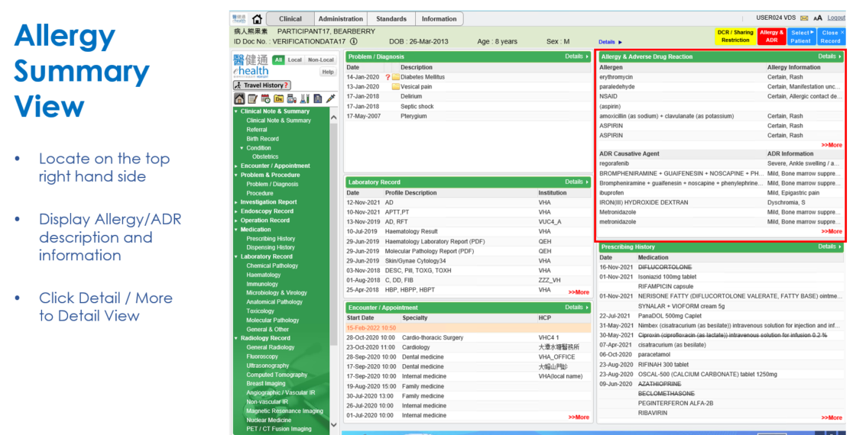
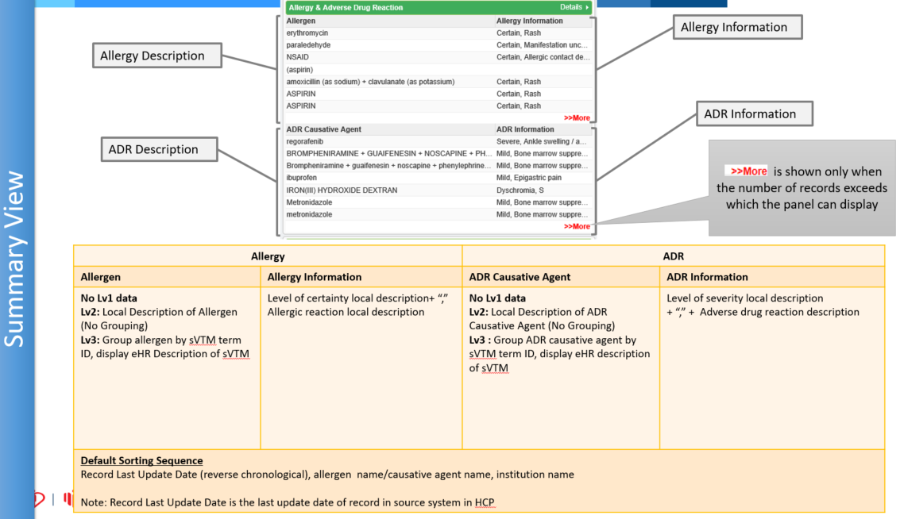
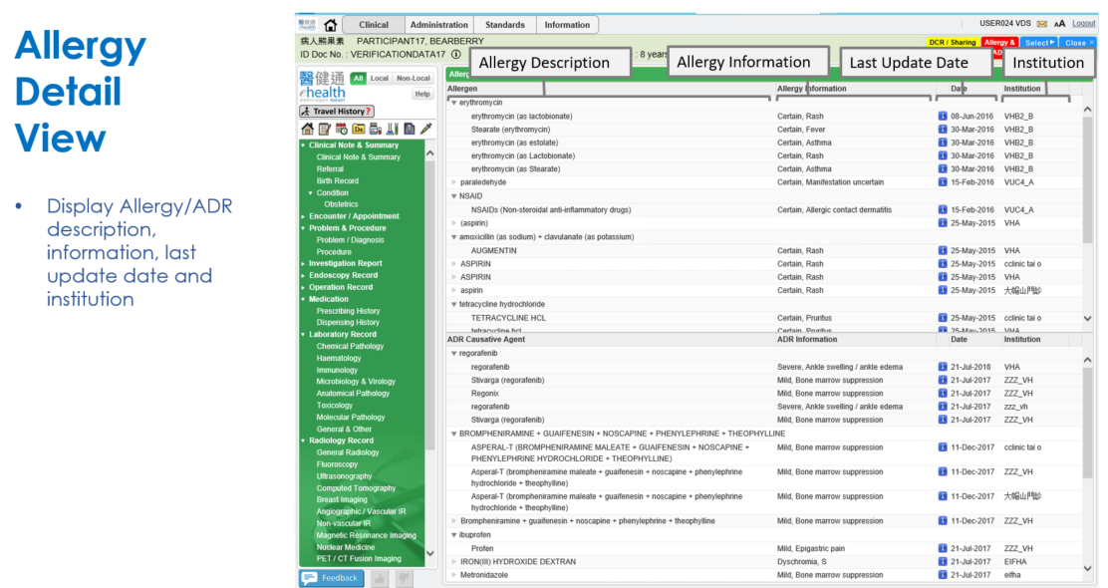
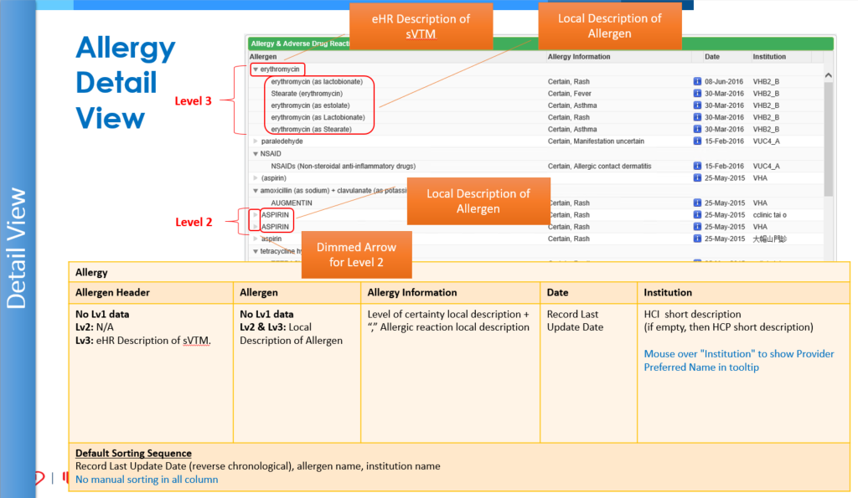
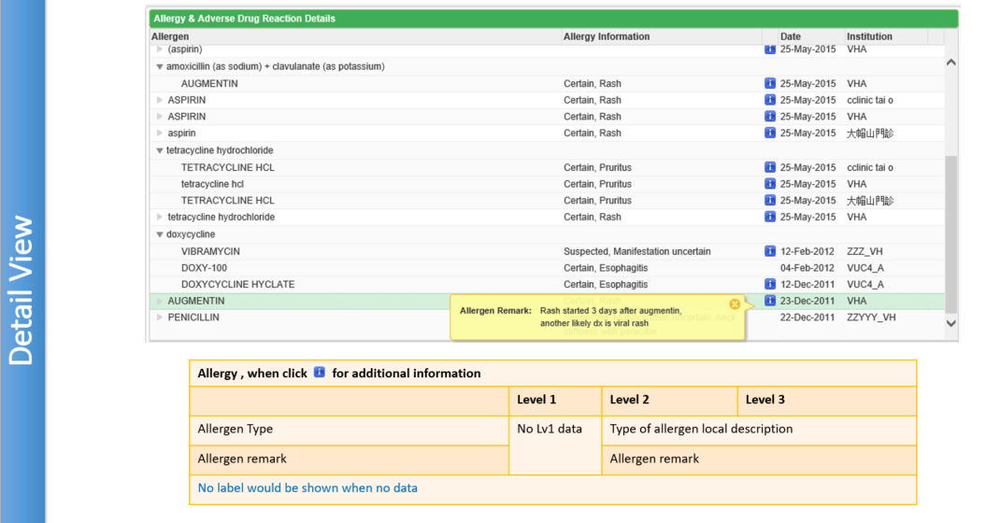
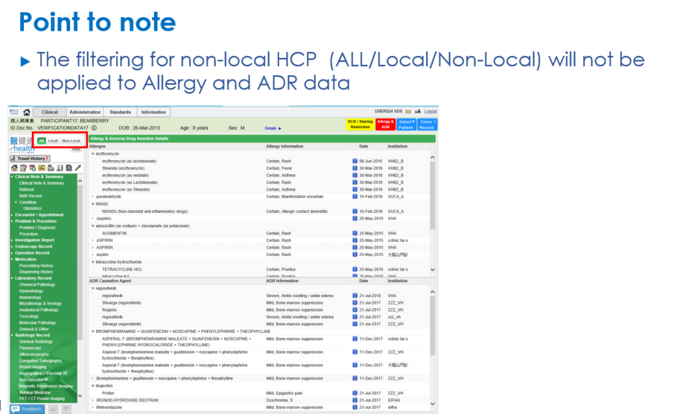

Appendix – Actual Data Values (Sample)
If the actual values entered are various from the test case, please provide actual values as below.
If the value is not inputted, please use [BLANK] to indicate that empty value is inputted intentionally.

